bandi.santoshi45@gmail.com

^^^^^^^^^^^^^^^^^^^^^^^^^^^^^^^^^^^^^^^^^^^^^^^^^^^^^^^^^^^^^^

Agile

Scrum

Product backlog

Sprint backlog : Are the stories committed by the team

Sprint

Burn up-down chards

Retrospect

Epic

Story

Story points

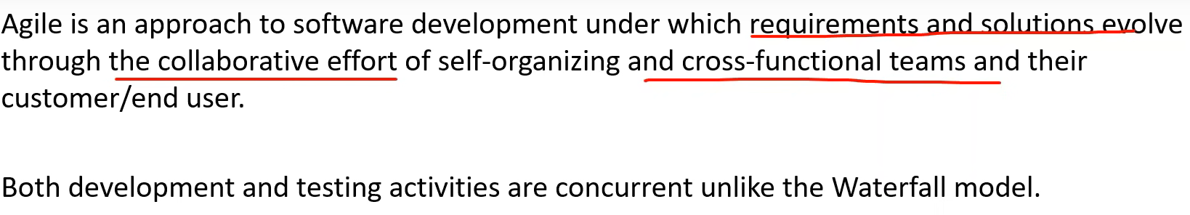

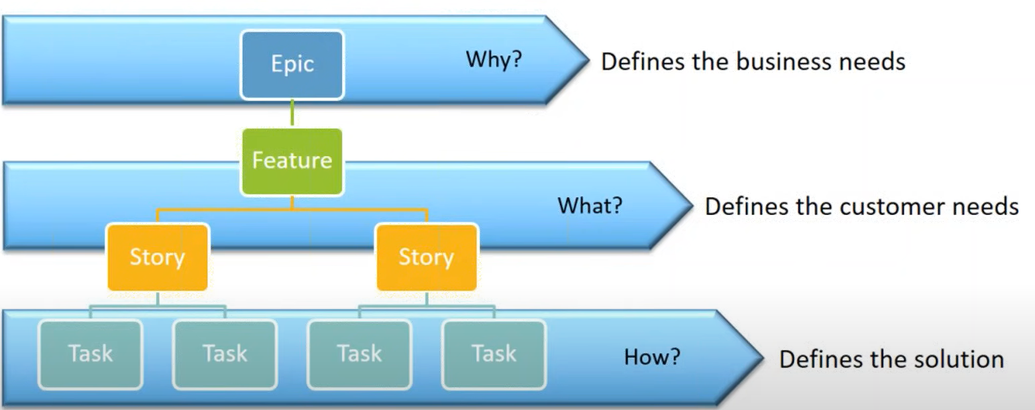

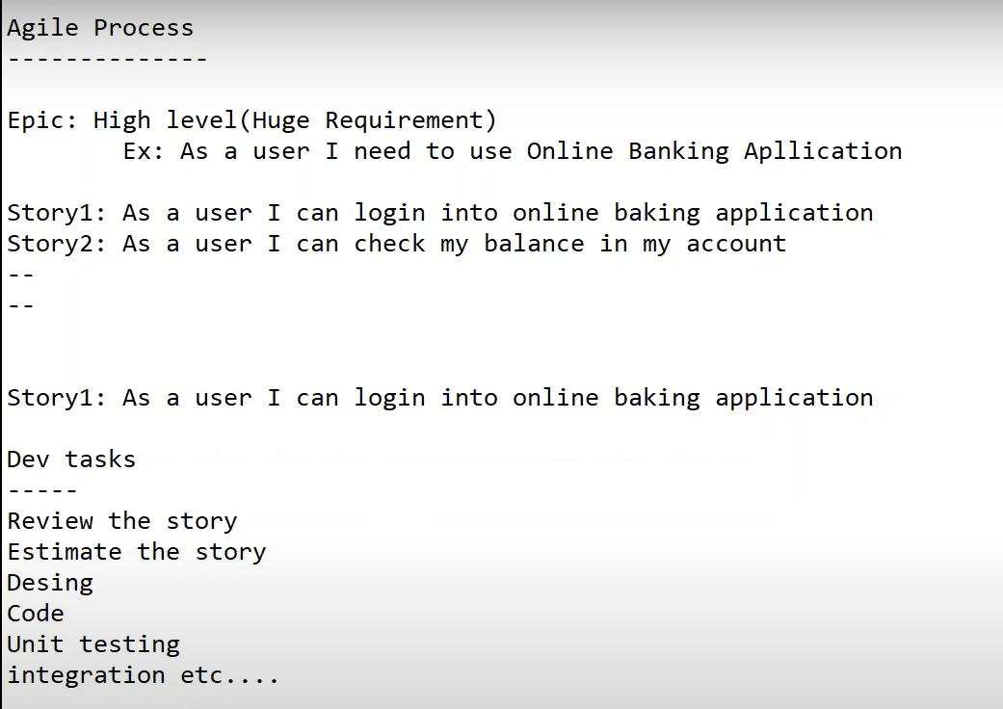

Scrum roles

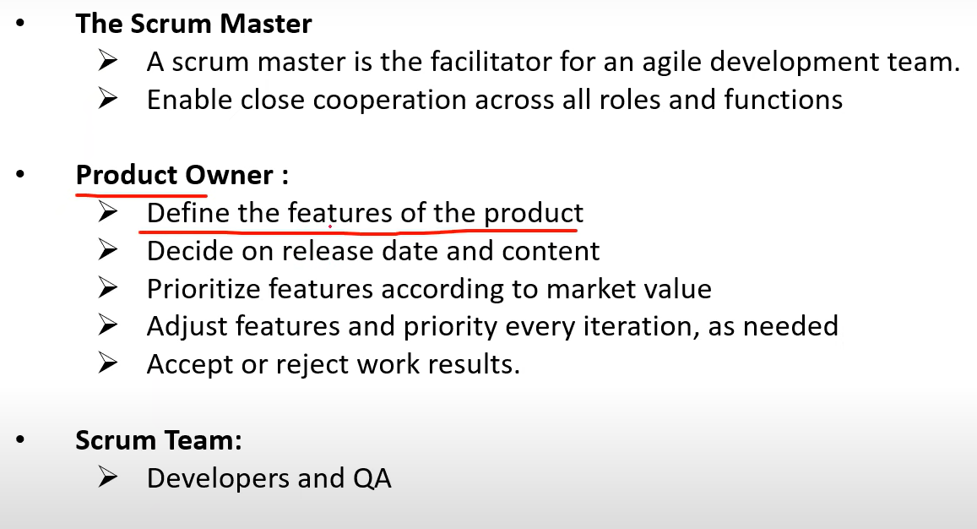

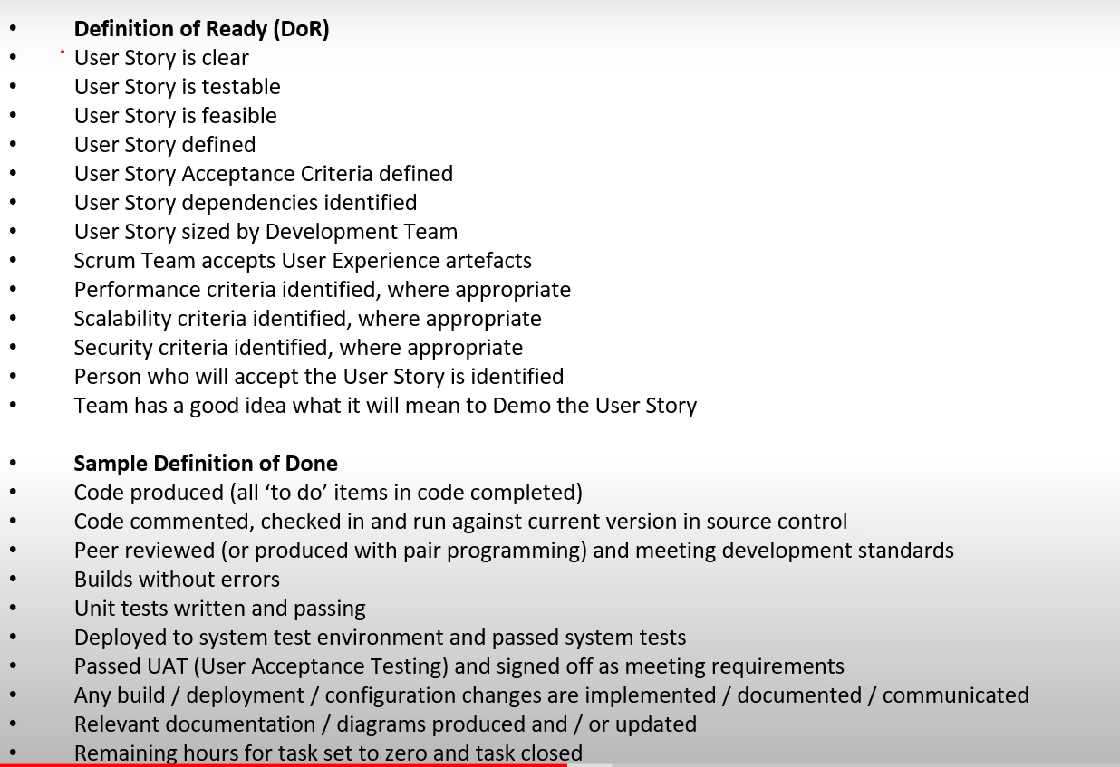

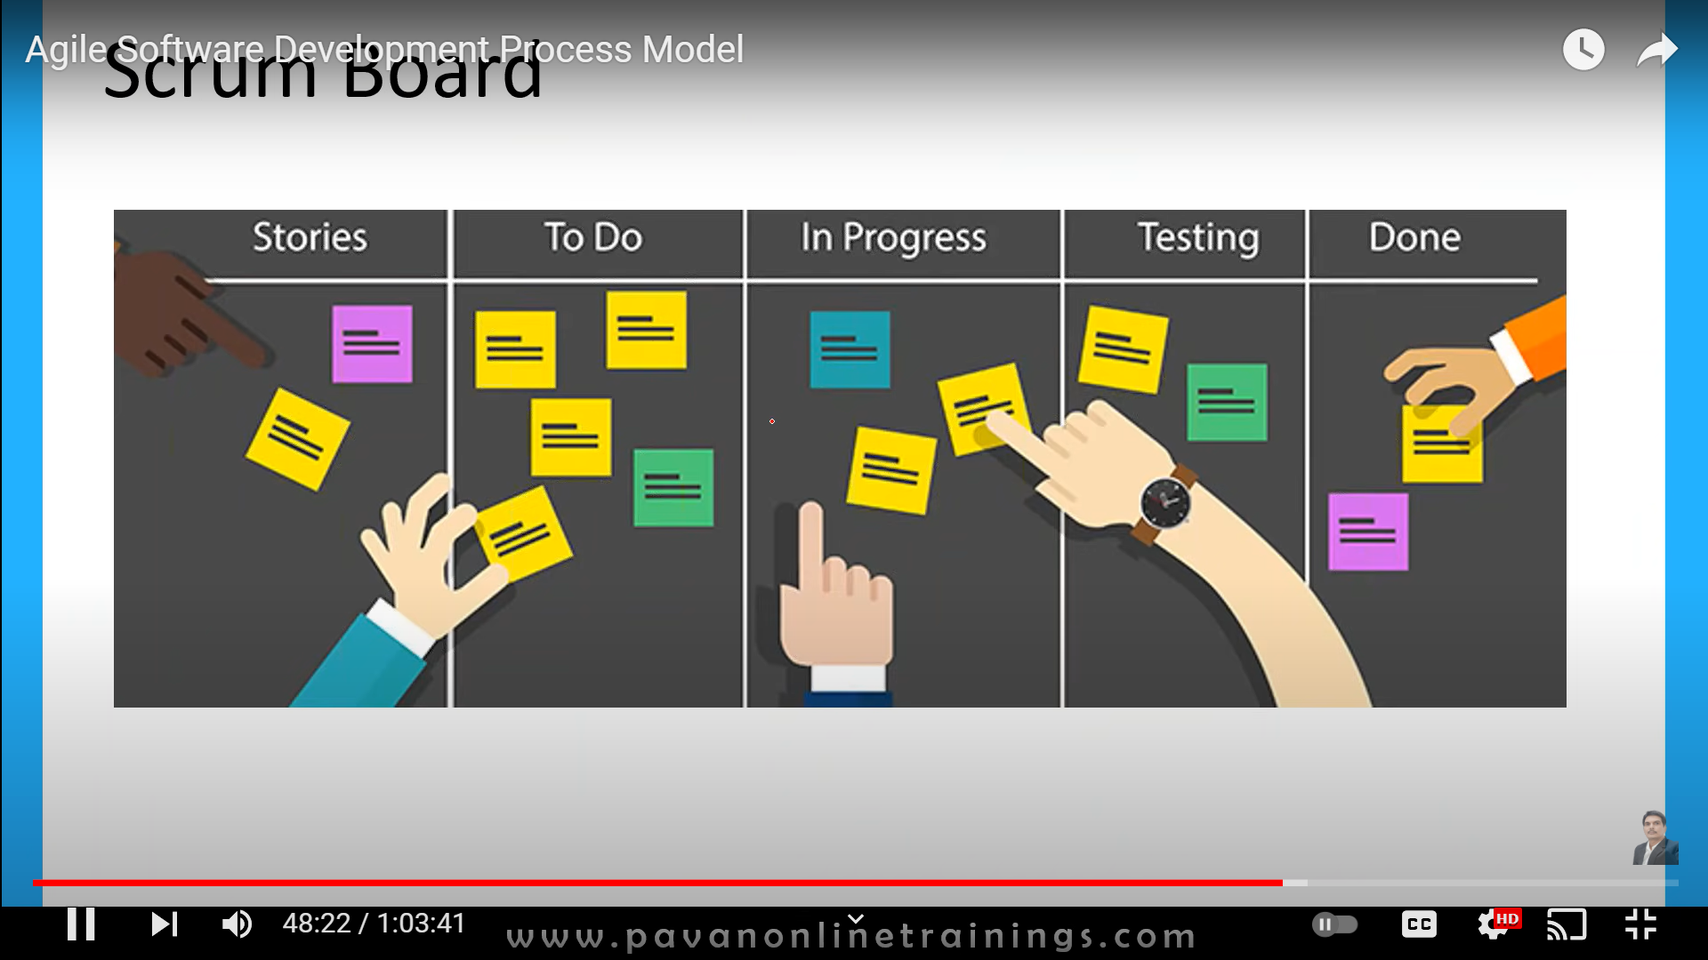

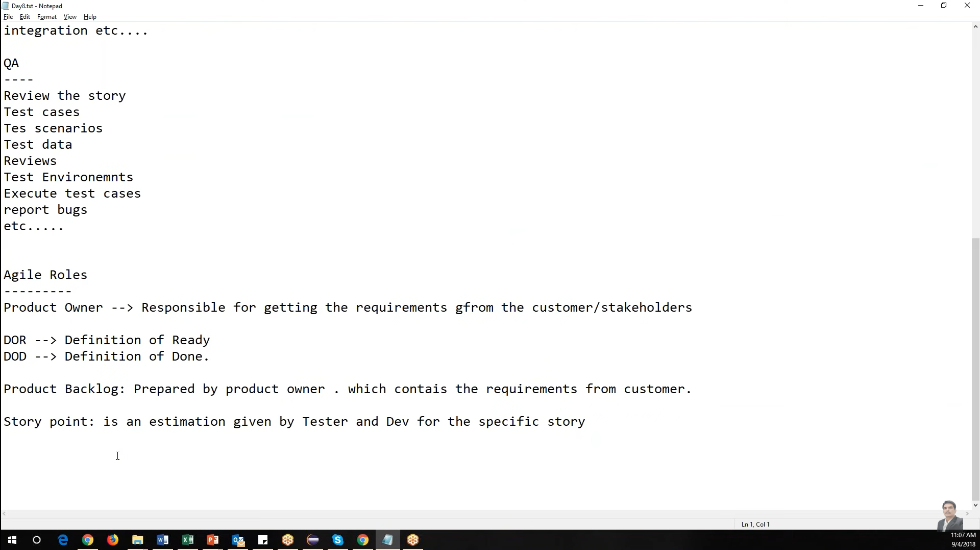

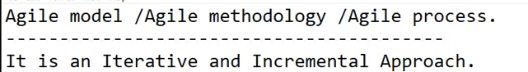

Iterative we are reaptingthe same steps again and again ( analyse,design , code, test)

Increment : Select few features in the beginning, then go on increment/ adding other features.

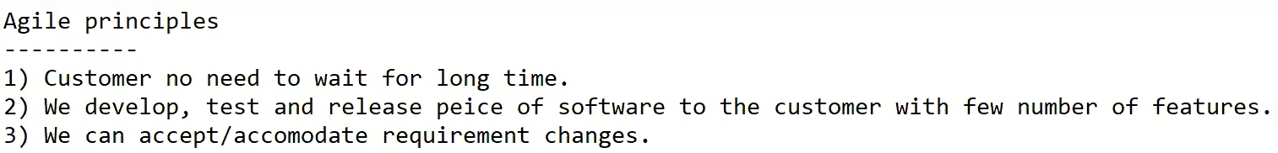

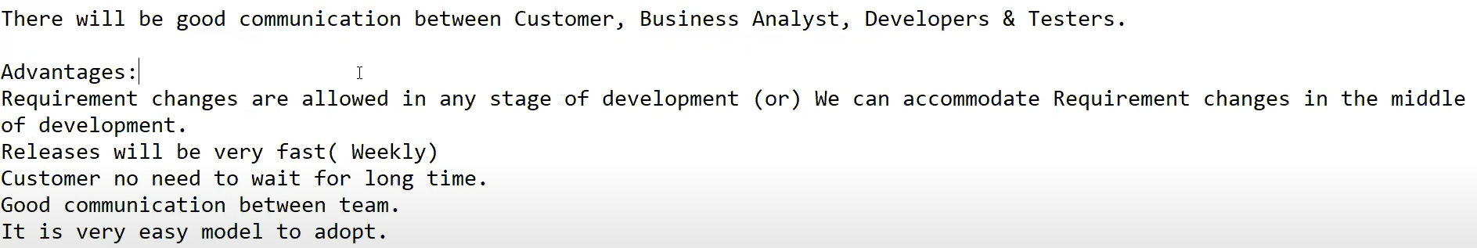



Scrum is a framework through which we build s/w product by following agile principles.

Scrum team

Product owner

Scrum master

Dev team

QA Team

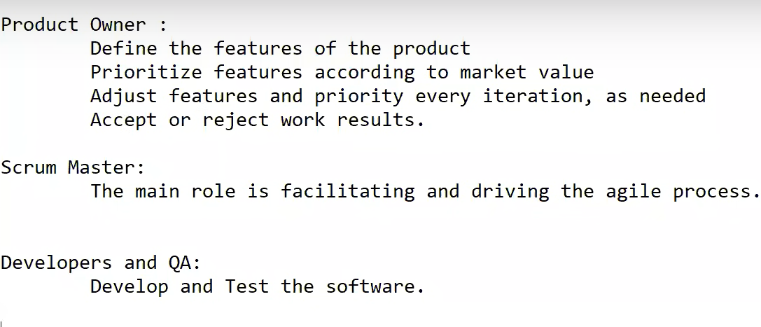

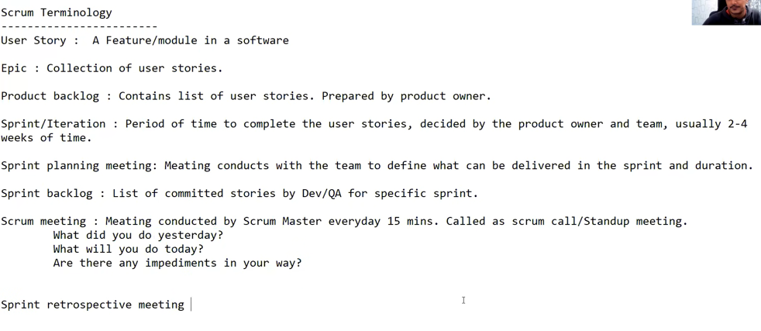



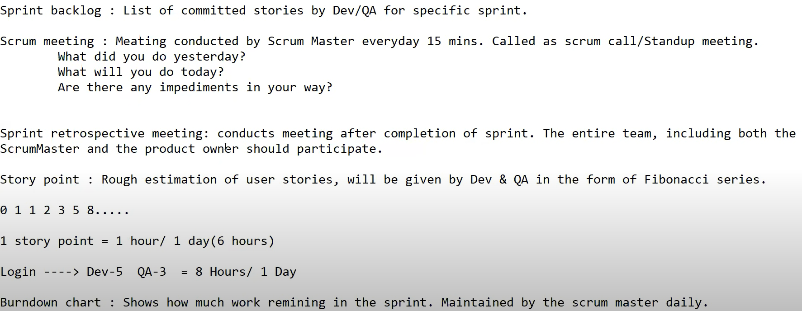

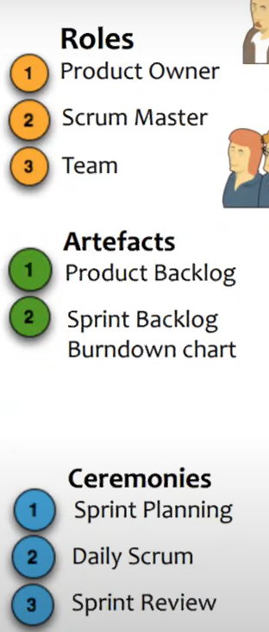

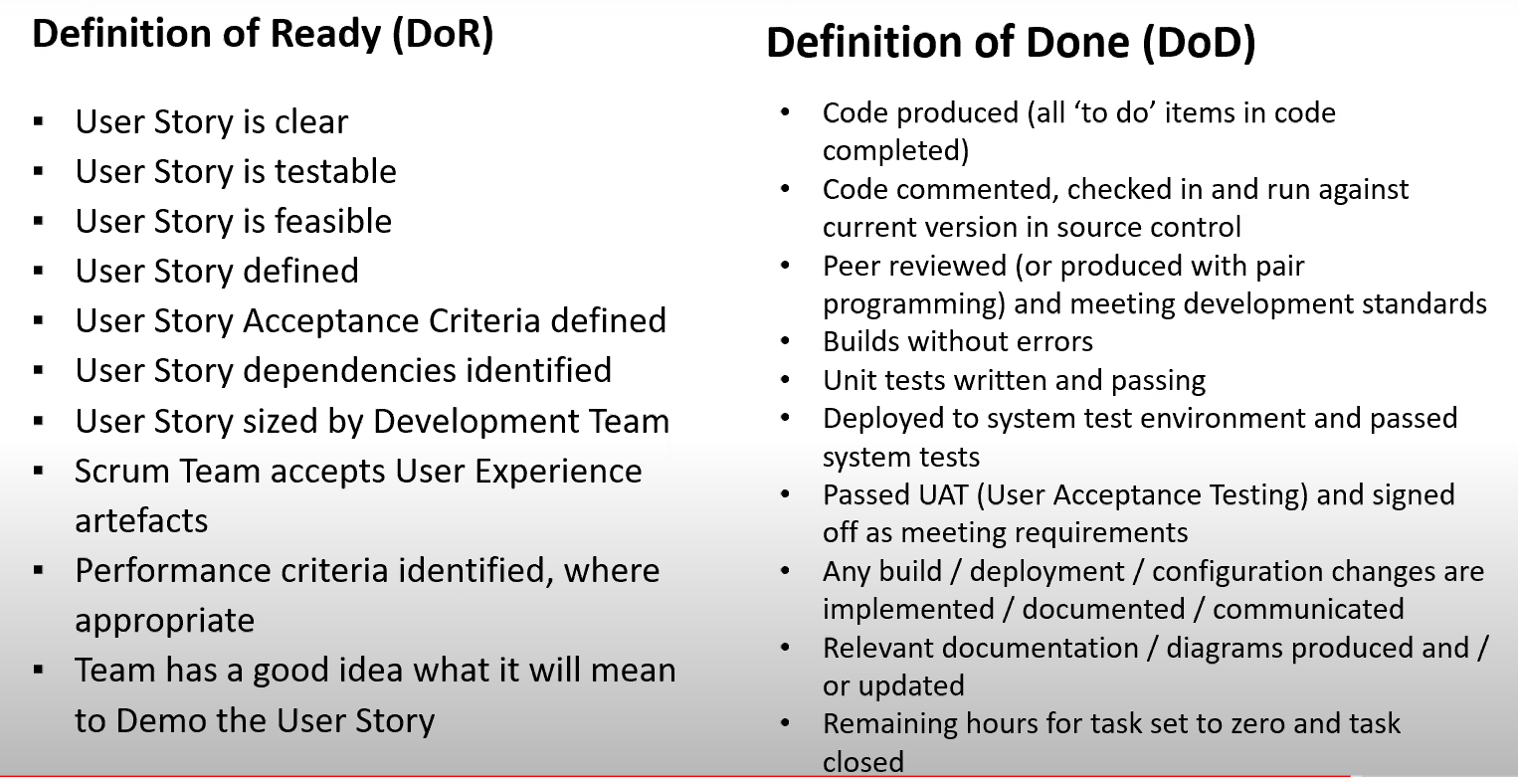

Sample product backlog

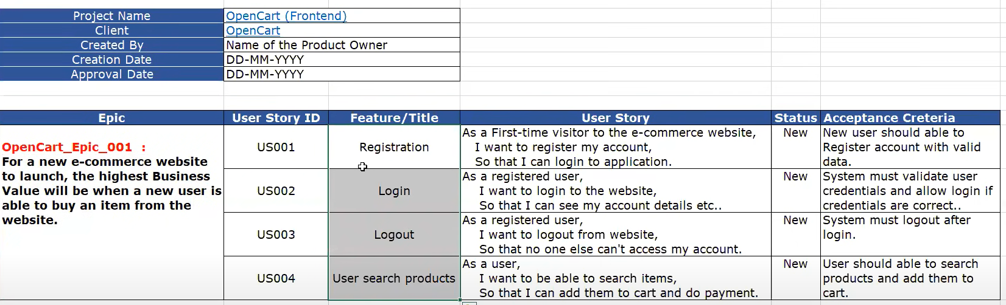

Sample Sprint backlog

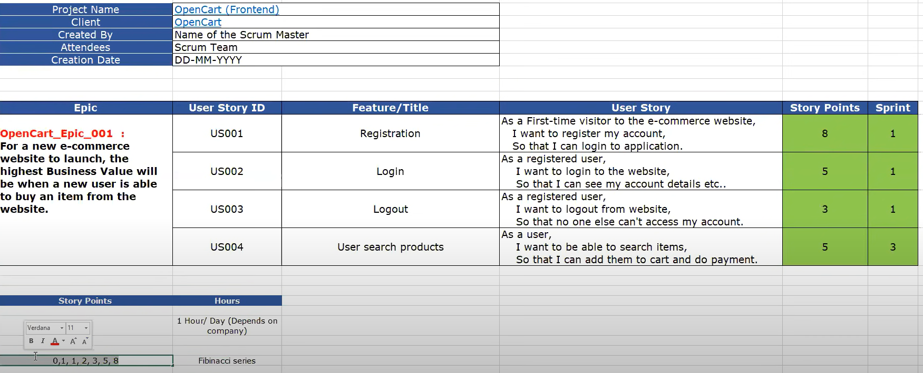

Tasks

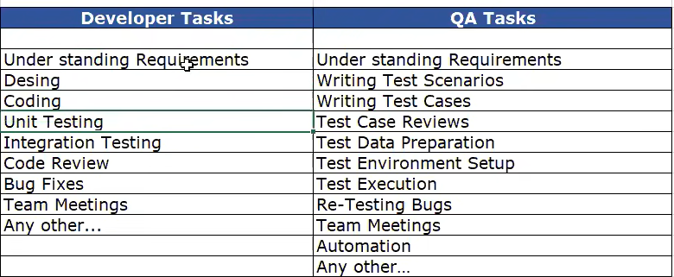

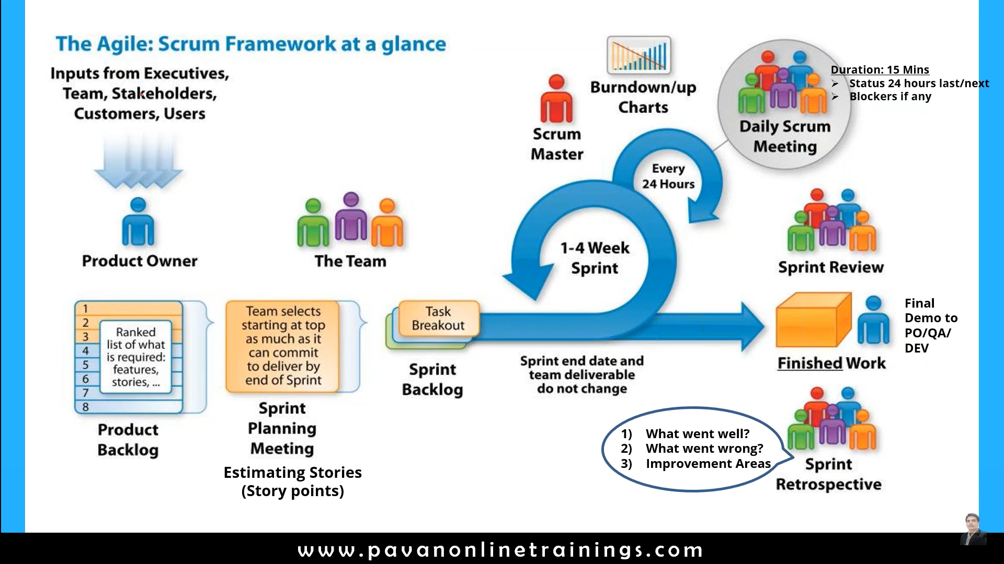

^^^^^^^^^^^^^^^^^^^^^^^^^^^^^^^^^^^^^^^^^^^^^^^^^^^^^^^^^^^^^^^^^^^^^

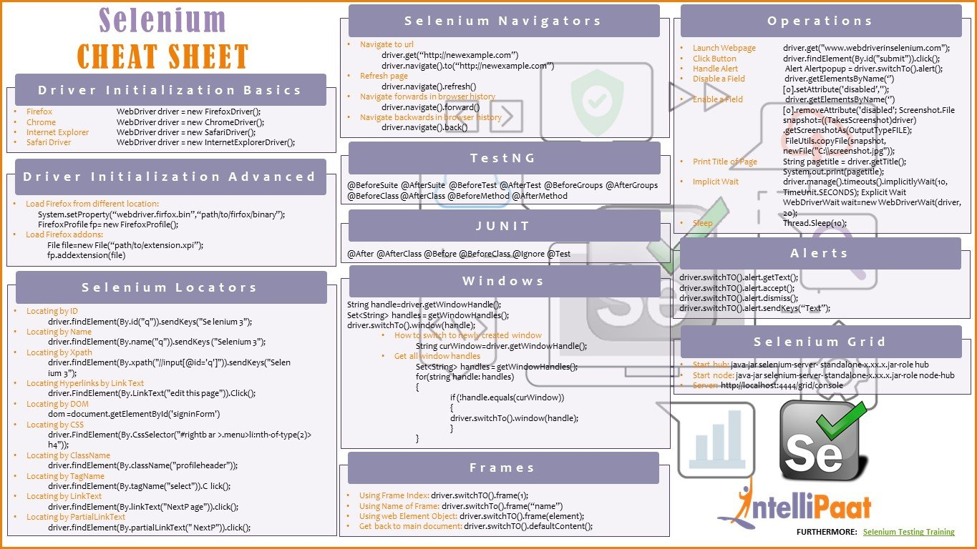

**^^^^^^^^^^^^^^^^^^^^^^^^^^^^^^^^^^^^^^^^^^^^^^^^^^^^^^^^^^^**

**Jira**

Jira is agile management tool. By adding the Zephyr plugin it provides test management tool.

What is JIRA?

JIRA is a software testing tool developed by the Australian Company Atlassian. It is a bug tracking tool that reports all the issues related to your software or mobile apps. The word JIRA comes from the Japanese word, i.e., "Gojira" which means Godzilla.

**What is a workflow?**

Workflow is defined as a movement of the bug/issue through various stages during its life-cycle

Created/Open

WIP ( Work In Progress)

Completed/Closed

**What can be referred to as an issue in Atlassian JIRA?**

In JIRA, an issue can be anything like a

Software bug

The project task

A help-desk ticket

The leave request form

**Agile Scrum activities in Jira**

1.Create project (Project menu 🡪 create project)

2.Add user/ people (Settings 🡪 User management , then provide emails of team)

3.Create backlog -Epic ( Project menu 🡪 backlog (left side bar))

Click on the version->create version, next provide version, description, start and end date

Click ob Eplc -> create epic, next provide epic name summary, reporter -> check create another if u want to create another epic🡪 create

* Epic is collection of stories.
* Story is a mall requirement

4.Create stories (click on Create🡪next select Story 🡪provide , summary and description 🡪reporter🡪 assignee 🡪 priority 🡪 label 🡪 epic link 🡪 sprint. Next click Create

5.Add story points (Under the backlog section 🡪 select the story 🡪 add story points)

6.Create sprint (Click on create sprint button 🡪 Drag and drop user stories to the sprint area )

7.Adding user stories to sprint

8.starting sprint (Click o start sprint button)

9.Adding sub tasks (Dev and QA will define the subtask. Select the user story 🡪 create task-> assign to the user. You can move the sub task to in progress or done – drag and drop or you can select the task and change the status )

10.Sprint life cycle ( to do 🡪 In progress 🡪 done)

11. Create test case in Jira manually (Install zyphre plugin) (Click on app 🡪 search for Zephyr scale 🡪 click-> try it. search 🡪 Zephyr Squad - Test Management for Jira 🡪 Try it) (Now you can create test as a issue,. If test is not visible then go to project settings and enable Zephyr )

To create test --> click on zephr 🡪 create test on click on “create” button

provide 🡪test case, test data, test result 🡪 click on tick mark

To add the test to the sprint 🡪 search test

Select the test=> click on the test -> test details

Test management activities (you need to install zephyr plugin)

1. Test cases
2. Test cycle
3. update test cases passed/failed/blocked
4. Report bugs
5. Generate reports

* Write test case Main page 🡪 zephyre 🡪 create test)
* Manually add test case -> Select the test 🡪 click on test details )

12. Import multiple test cases (Main page🡪 your project 🡪 zephyre 🡪 import test cases)

* Import test cases: Create test cases in excel by following the jira templete🡪 Click on project 🡪 zephyr squad🡪 Import test case -> choose the excel file -> when success🡪 Next

Start Row number = 2

Discriminator -> change of test case

Next

Do the jira columns to excel column mapping

click on Next 🡪 click on validate

When mapping is successful

click on begin import

To verify go to Zephyr sqad 🡪select test case

13. Creating test cycles

* Select project🡪Zephyr squad 🡪 cycle summary
* Click on create new test cycle
* Provide all the details and click on Save

14. Add test case to the cycle

* Once the test cycle is created. We need to add test cases to test cycle
* Next go to test case -> select a particular test case 🡪 Click on add to test cycle 🡪 select the test cycle ->assign it to user

Or

* Select the cycle summary 🡪 click on Add tests button 🡪 provide the test case name

You can verify by clicking on cycle summary

Report the bug by creating a issue 🡪 Issue type =”Bug”

15. execute/update test case

* Click Zephyre squal 🡪 search test execution -> Select the test case 🡪 click on test execution icon 🡪 Go the status and update the status

16 reporting bugs

* Click on Create button 🡪 issue type =”Bug”
* Click on “Issues” to see all the issues

16 .Reports in zephyre

* Back to project 🡪 click on Reports 🡪 select the type of chart
* To see test related reports 🡪 Zephyr 🡪

17. Traceablility matrix

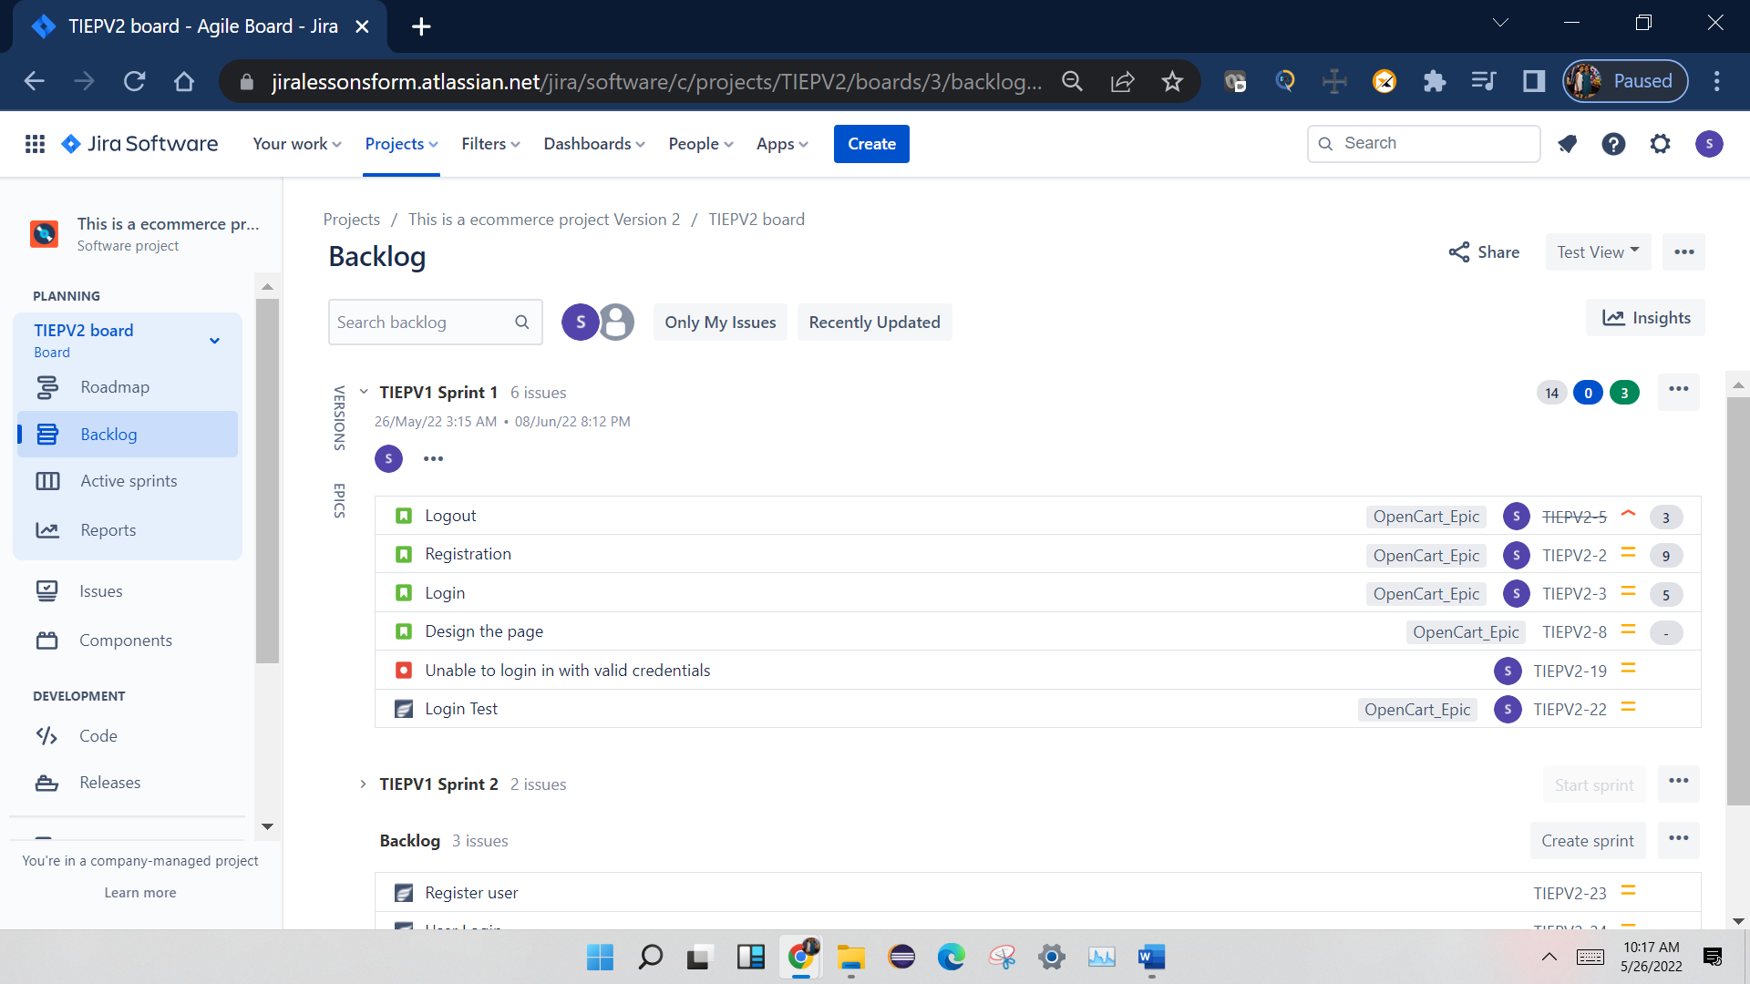

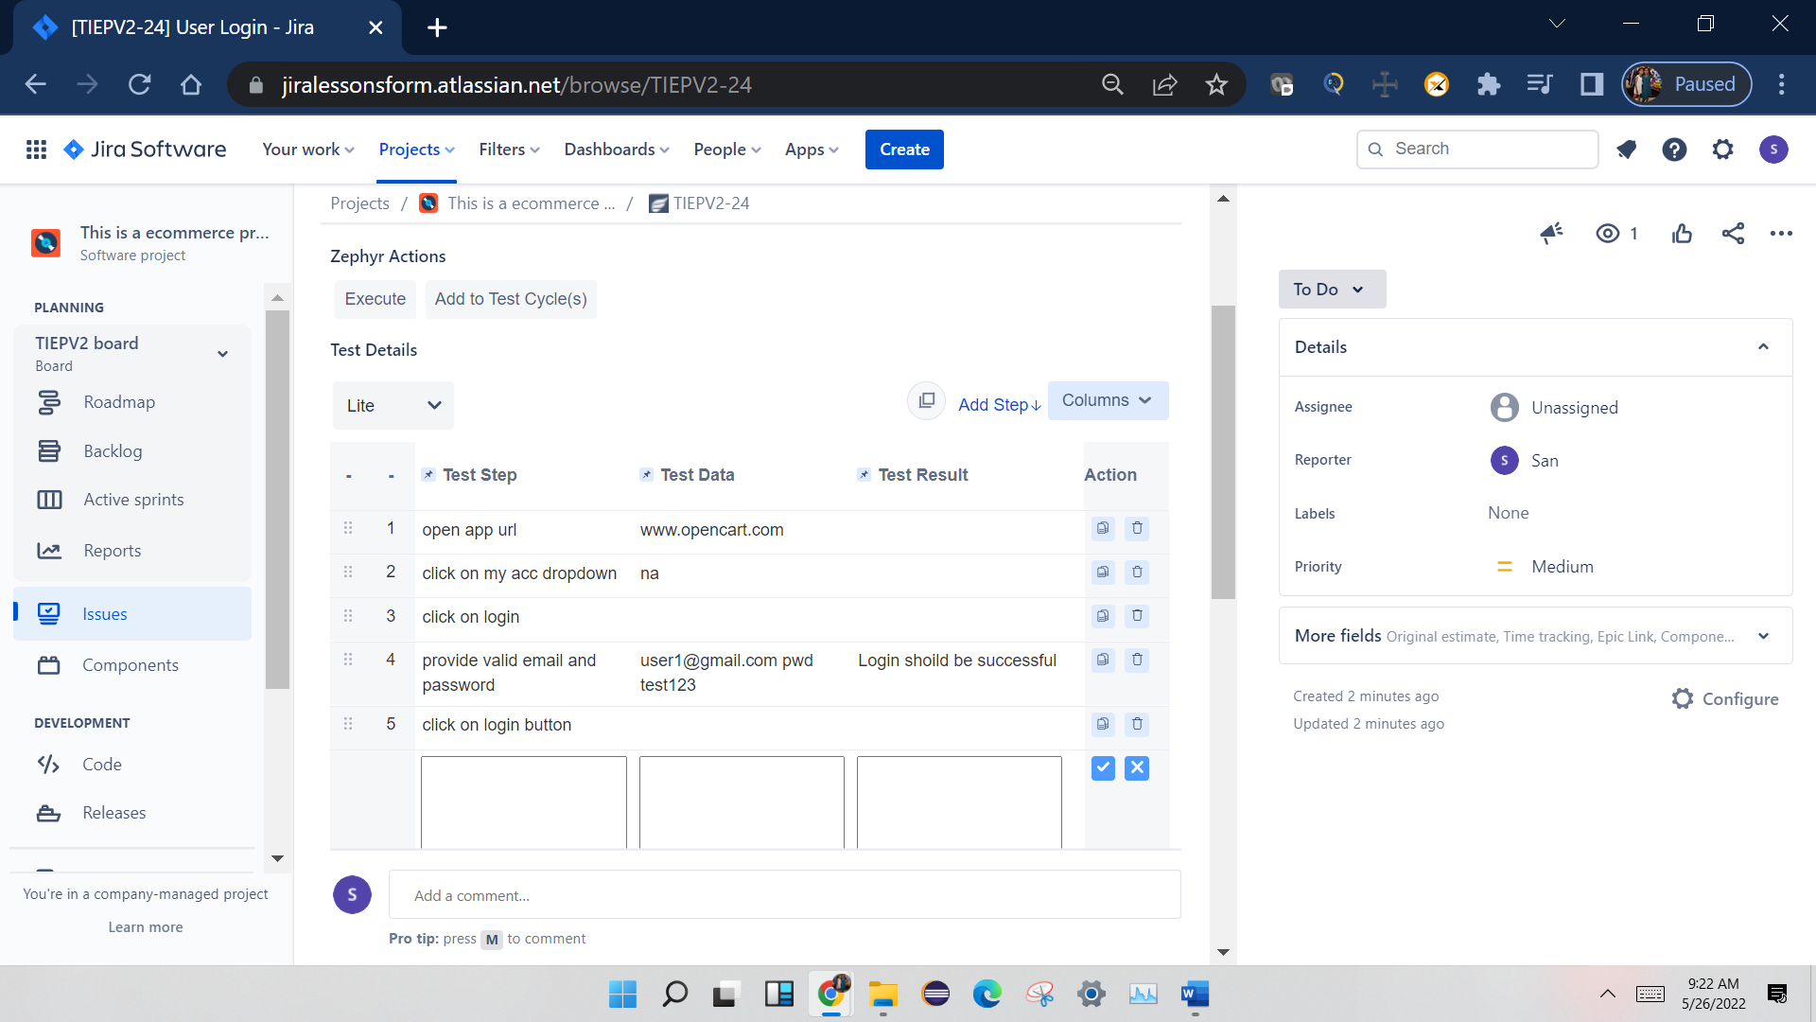

**Javatpoint**

<https://www.javatpoint.com/agile-interview-questions>

# Top 20 Agile Interview Questions and Answers

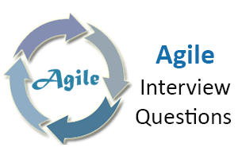

Here, we are giving the most relevant **Agile Scrum interview questions with answers** and hope these questions will help you while preparing for the agile scrum interview.

### 1) What is an agile or agile methodology?

Agile is an iterative approach of software development methodology using short iterations of 1 to 4 weeks. Due to the agile methodology, the development process is aligned to deliver the changing business requirement.

### 2) What are some quality strategies of agile?

Some quality strategies of agile are:

* Iteration
* Re-factoring
* Dynamic code analysis
* Short feedback cycles
* Reviews and inspection
* Standards and guidelines
* Milestone reviews

### 3) What are an agile manifesto and its principle?

Agile manifesto uncovers the better way of developing software by doing it and helping others to do it. Agile has 4 manifesto and 12 principles which defines:

* Individuals and interactions, i.e., self-motivating and self-organized should be encouraged.
* Demonstrate the working software at regular intervals with comprehensive documentation.
* Customers are collaboration over contact negotiation.
* Responding to change over following a plan.

AD

**The principles of agile manifesto are-**

1. **Customer Satisfaction:** Manifesto provides high priority to satisfy the costumer's requirements. Customer satisfaction is done through early and continuous delivery of valuable software.
2. **Welcome Change:** Making change during software development is common and inevitable. Every changing requirement should be welcome, even in the late development phase. Agile process is used to increase the customer's competitive advantage.
3. **Deliver the Working Software:** Deliver the working software frequently, ranging from a few weeks to a few months with considering the shortest period.

[Read more](https://www.javatpoint.com/agile-manifesto)

### 4) Is there any disadvantage of the agile model (SDLC)?

Disadvantages of Agile SDLC:

1. The development team should be highly professional and client-oriented.
2. New requirement may be a conflict with the existing architecture.
3. With further correction and change, there may be chances that the project will cross the expected time.
4. There may be difficult to estimate the final coast of the project due to constant iteration.
5. A defined requirement is absent.

[Read more](https://www.javatpoint.com/agile-sdlc)

### 5) What are the burn-up and burn-down chart?

The burn-up chart depicts the amount of work done in the project, whereas the burn-down chart illustrates the amount of work remaining in the project. Thus, the burn-up and burn-down are used to describe the progress report of the project.

### 6) What do you understand by Daily Stand-Up?

The daily stand-up is the day-to-day meeting (mostly in the morning) in which the whole team meets around 15 minutes to find the answer for the following three questions:

* What was done yesterday?
* What is your plan for today?
* Is there any obstacle that restricts you to complete your task?

### 7) What do you understand about Scrum?

**Scrum is a framework** that helps agile teams work together to develop, deliver, and sustain the complex product in the shortest time. The product provides by scrum team in this shortest period is known as a **sprint**.

### 8) What are the different roles in Scrum?

There are three different roles in scrum. These are the Scrum Master, Product Owner, Agile Development Team:

* **Scrum Master:** The Scrum Master is a team leader and facility provider who help the team member to follow agile practices so that they can meet their commitments and customers requirements.
* **Product Owner:** The Product Owner is one who runs the product from a business perspective. He defines the requirements and prioritizes their values.
* **Agile Development Team:** Agile development team provides the judgment on the technical feasibilities or any dependencies.

### 9) What are the responsibilities of the Scrum Master?

The critical responsibility of Scrum Master includes:

* Tracking and monitoring project development.
* Understanding the user requirement correctly.
* Work to obtain the project properly.
* Improving the performance of the team.
* Organized meetings and resolve issues.
* Communicate and report to the customer and development team.

### 10) What are different ceremonies and their importance in Scrum?

To clearly express the Scrum planning, Scrum review, Scrum Daily stand up, and scrum retrospective is the purpose of the ceremony. The importance of these ceremonies is to use sprint as per your project.

### 11) What do you know about Scrum ban?

Scrum-ban is a Scrum and Kanban-based model for software development. This model is used in the project that needs continuous maintenance, various programming error, or some sudden changes.

### 12) What do you understand by the term agile testing?

The agile testing is the software testing process which is fully based on the principle of agile software development. It is the iterative approach where the user story becomes the output of the collaboration between the product owner and the development team.

### 13) What are the major principles of agile testing?

Some of the essential principles of agile testing are:

* Customer satisfaction
* Face to face communication
* Sustainable development
* Continuous feedback
* Quick respond to changes
* Successive improvement
* Self-organized
* Focus on essence
* Error-free clean node
* Collective work

### 14) What are the skills of a good agile tester?

The agile tester is one who implements the principle of agile software development principles for software testing. An excellent agile tester has the following skills:

* He must be familiar with the principles and concept of agile.
* He must be excellent communication skill to communicate with the team and the clients.
* He can set the priority of a task according to customer requirements.
* He should able to understand the customer requirement properly.
* He should understand the project risk due to changing demand.

### 15) Name the agile frameworks.

Some of the agile frameworks are:

* Scrum
* Kanban
* Feature Driven Development
* Test Driven Development

### 16) Is it ever suggested to use waterfall over Scrum? If yes, explain when.

Yes, sometimes we use waterfall module over scrum. This is because when the client requirement is simple, small, well-defined, fully understood, predictable, and the subject does not change until the project complete.

### 17) Name some methodologies and development where you have used the agile model.

While answering this type of question, keep in mind to mention those methodologies from which you are familiar whit. Some of the methodologies where agile is used are:

* Crystal methodologies
* Lean software development
* Dynamic development
* Feature-driven development

### 18) What was the length of sprints/iterations in your project?

It is a common question for experienced people. The idea behind is to judge in which kind of environment you have worked? There will be follow up of the question that the length fixed in the beginning and never changed? Did you try with less than this length or more than that?

### 19) What is the difference between the agile & traditional way of working?

The traditional way of development is that which follow the sequential where design -> development -> testing etc. is performed whereas, in agile development, all of this is done in every iteration/sprint.

### 20) Why does Scrum encourage the use of automated testing for projects?

Due to faster possible delivery of the project, the Scrum development encourages to use automated (automated performance or automated regression) testing. While answering this question, you should explain some tools that you have used for automated testing.

^^^^^^^^^^^^^^^^^^^^^^^^^^^^

[Software Testing Help](https://www.softwaretestinghelp.com/)

<https://www.softwaretestinghelp.com/agile-interview-questions/>

### Top Agile And Scrum Interview Questions

Let’s start with the top Agile Scrum Methodology interview questions.

**Q #1) How long the Scrum cycle last?**

**Answer:** Basically, the Scrum cycle depends on the project size and team size. Team size may vary from 3 members to 9 members.  Normally, it takes 3 to 4 weeks to complete a Scrum sprint. On an average, a scrum sprint ends in 4 weeks.

**Q #2) What is the scrum of scrums?**

**Answer:**Suppose there are  7 teams working on a project and each team has  7 members. Each team leads its own particular scrum meeting. Now to coordinate among the teams a separate meeting has to be organized, that meeting is called Scrum of Scrums.

[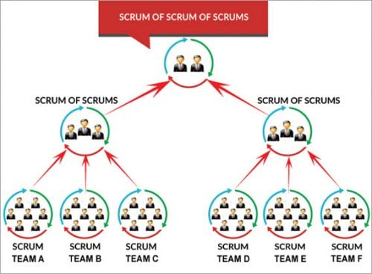](https://www.softwaretestinghelp.com/wp-content/qa/uploads/2017/11/Scrum-of-Scrums-e1509975592287.jpg)

An ambassador (a designated person who represents team) represents its team in the scrum of scrums.

**Few points discussed in the meeting are:**

1. The progress of the team, after the last meeting.
2. The task to be done before the next meeting.
3. Hindrance which the team had faced while completing the last task.

**Q #3) Explain the term ‘increment’?**

**Answer:**When the team finishes the sprint, hopefully, they have completed everything they forecasted. The sum of all the product backlog items which were completed in a sprint is called increments. This new increment also has the value of increment of the previous sprints.

**Q #4) What is Sashimi?**

**Answer:**Sashimi is a Japanese word that means a pierced body. Basically, it is a Japanese dish that consists of fresh meat or fish, sliced into thin pieces. Each piece is similar in taste when compared with the other pieces.

Sashimi in scrum methodology means every phase of the software development cycle in a sprint which includes requirement analysis, planning &  design, development, testing, documentation is complete or not and the product is ready to be displayed, etc.

**Q #5) What are impediments?**

**Answer:**Any hindrance which prevents the smooth flow of work or due to which the team is not able to perform its task in a better way is what we call ‘impediments’.

**Q #6) Explain ‘scrum poker’ or ‘planning poker’ technique?**

**Answer:**Scrum poker, also called as planning poker, is a card-based estimation technique which is based on a general agreement.

1. To start it, the agile user story is read either by the customer or the owner and the estimator understands its features.
2. Each estimator has planning cards with different no. on it like 0,1,2,3,5,8 and so on. These values on the card are ideal days or story points.
3. Estimator select cards based on their estimation by discussing features set by the product owner.
4. If a common value is selected, it is an estimate, if not they discuss their max. and min. estimation.
5. This process is repeated until a general agreement is reached.

**Q #7) What are the principles of agile testing?**

**Answer:** **Some major principles of agile testing are:**

* Customer satisfaction
* Bug-free clean code
* Changes are welcome by customer
* Whole team, business people and developers work collectively
* Instead of lengthy documentation, focus on the essence
* It focuses on face to face conversation
* It promotes sustainable development

**Q #8) What are the disadvantages of the agile model?**

**Answer: Some of the disadvantages of using the agile model are as follows:**

* Not easy to predict: When you encounter a large project, it is not easy to get an idea of how much effort will it require.
* If the guidelines given by the customers are not properly grasped, then final outcome of the project is not as per customer satisfaction.
* Sometimes focusing on design and documentation is not proper
* High-level decisions are under the hand of Veterans, if not combined with non-experienced ones, freshers have little scope to grasp proper knowledge.

**Q #9) When to use the agile model?**

**Answer:**There are some development and methodologies where you can use agile like feature-driven development, lean software development, crystal methodologies, dynamic development.

**Q #10) What is the Release candidate?**

**Answer:**The release candidate is a code /version /build released to make sure that during the last development period, no critical problem is left behind. It is used for testing and is equivalent to the final build.

**Q #11) In what way does agile testing(development) methodology differ from the other testing(development) methodologies?**

**Answer:**In [Agile methodology](https://www.softwaretestinghelp.com/agile-scrum-methodology-for-development-and-testing/), the code is broken into small parts and at a time, only that particular code is worked or tested. Continuous communication on the particular code part is done by a team so that the focus is only on that particular code. This makes the agile process more flexible and focused.

**Q #12) Can agile methodology also be applied in other than software testing and development projects?**

**Answer:**There are several places where agile methodology can be applied in the field of biochemistry, biophysics, bio-medical or at the place where there is insufficient data, where the project needs to be completed in a small team, where to work in unknown and there are several areas.

**Q #13) How do you know if you are using agile development?**

**Answer:**Whenever you are using certain things like test-driven development, time-boxed task board, class responsibilities collaborators, daily stand up meeting, pair programming, continuous integration, reviews and much more, you will get to know that you are using agile development

**Q #14) Explain what is a story point in the scrum?**

**Answer:**It can be considered as a unit to estimate the total efforts required to complete or to do the particular task or implementing a backlog.

**Q #15) What does the X and Y-axis of the burndown chart?**

**Answer:**In burn down, chart X-axis shows working days and Y-axis shows remaining efforts.

[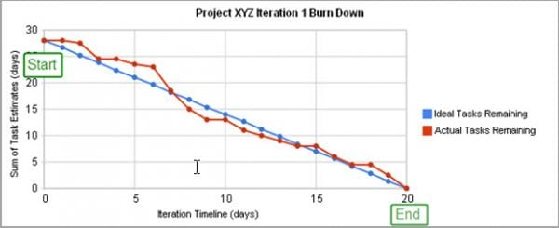](https://www.softwaretestinghelp.com/wp-content/qa/uploads/2017/11/Project-XYZ-e1509975673494.jpg)

Here, in the image blue line depicts the ideal time suggested for completing the project. **For Example,** in a project ideally, 28 tasks (efforts) are pending on the starting day of the project. And the project is scheduled to be completed in 20 days. So, on the 20th day, zero tasks (efforts) should remain, which means the project should get completed.

On the other hand, the red line depicts the actual task (efforts) given with respect to the days. Here on day 5, 7 tasks need to be completed as per planning, however, in actual only 4 tasks were completed.

Thus, it provides proper tracking down of the progress of the project and thereby helps in improving the efficiency and on-time taken to deliver the project.

**Q #16) What are the main roles in the scrum?**

**Answer:**

1. **Scrum Team**: Scrum team is made by an individual person who works collectively to achieve a particular task. The team works in a bond to deliver committed and requested products.
2. **Scrum Master**: Scrum Master is responsible for the proper execution or working of the scrum team. Being a servant – leader and a coach, he ensures the proper productivity of a team towards scrum sprint goal.
3. **Product Owner**: The product owner has the responsibility to deliver a complete picture of what to build and to convey that idea to the team.

**Q #17) What is a product burndown chart?**

**Answer:**A description in the form of the graph which shows implemented and not – implemented product backlog is called the burndown chart.

**Q #18) What is the sprint burndown chart?**

**Answer:**A graph used to describe no. of implemented/non-implemented sprint in the Scrum cycle.

**Q #19) What is the Release burndown chart?**

**Answer:**The graph used to depict the pending release which was earlier planned is called Release burn down the chart.

**Q #20) What is the defect burn down chart?**

**Answer:** The number of defect identified and removed is represented by the**defect**burn down**chart.**

**Q #21) What is the sprint planning meeting?**

**Answer:**A sprint planning meeting is joined by all entities like scrum master, product owner and whole scrum team where they discuss the priority features of the team and product backlog items.

**Q #22) What is a Sprint Retrospective meeting?**

**Answer:**This is mostly the last part of the sprint or may be done after the sprint review meeting. [Scrum](https://www.softwaretestinghelp.com/agile-scrum-methodology-for-development-and-testing/) master and the whole team participate in it. They discuss ‘ what was good during the sprint’,’ what was bad’,’ what needs to be improved’. It generally lasts for 2-3 hrs.

**Q #23) What do you know about ‘build-breaker’?**

**Answer:**When sometimes developer accidentally commit bug in the software and when such bug stops the compilation process and generates the warning or failure in the normal execution of testing, we say that the build is broken and the major priority of the tester is to get back again to the normal stage by resolving the [bug](https://www.softwaretestinghelp.com/how-to-write-good-bug-report/) issue.

**Q #24) Tell me something about Kanban?**

**Answer:**Kanban is a tool that helps the team to overlook the work ie., its progress. Progress, as well as the status of your current development story, is perfectly described using kanban and more accurately it is done by the ‘Kanban board’.

Kanban board allows you to write the whole scenario of your project at a single place so that you can get a perfect picture of the bottleneck, a task done, workflow progress or basically the complete status of your project.

**Q #25) Describe the places where ‘Scrum’ and ‘Kanban’ are used?**

**Answer:**‘Scrum’ is used when you need to shift towards a more appropriate or more prominent process while if you want improvement in running the process without much changes in the whole scenario, you should use ‘Kanban’.

**Q #26) Why aren’t user stories simply estimated in man-hours?**

**Answer:**Estimation of user stories on the basis of man-hours can be done but preferably not. You won’t be able to concentrate on the quality product to be delivered to the customer. Moreover, you will concentrate on the cost and budget of the management while using man-hours.

Instead of that, one can use story points, as it provides the complete idea about both the complexity of work and required efforts

**Q #27) Name three other Agile frameworks?**

**Answer:**[Test Driven Development](https://www.softwaretestinghelp.com/testers-in-tdd-bdd-atdd-techniques/), Feature Driven Development, and Kanban.

**Q #28) Should scrum master remove impediments on behalf of the scrum team?**

**Answer:**Scrum master can do that, but he should not. The scrum master should neither over-rule nor pamper his/her team. Initially, there may be chances of failure, unplanned excursions or dead-end where the team can trap, here scrum master should support them and show the proper way of getting out of it. A scrum team should be independent to take its own decision.

**Also read =>>**[**Scrum Master interview questions and answers**](https://www.softwaretestinghelp.com/scrum-master-interview-questions/)

**Q #29) How does agile testing (development) methodology differ from another testing (development) methodologies?**

**Answer:**In agile testing methodology, the entire testing process is broken into a small segment of codes and in each step, these codes are tested. There are several processes or plans involved in this methodology like [communication](https://www.softwaretestinghelp.com/how-to-improve-communication-skill/) with the team, short strategical changes to get the optimal result, etc.

**Q #30) How would master recommend following-up on action items?**

**Answer:**The best way of doing that is by setting a follow-up of the task/list to be done by the member pick at team retrospective. The scrum master should collect the information or status of the action items from the previous retrospective before moving further with the new one and if any of the action items remain uncovered or untreated, the cause or the reason should be known to avoid it’s further happening.

**Q #31) Which are the top agile matrices?**

**Answer:**

1. **Velocity**: Tracking your velocity gives you a clear idea about your progress, capacity, etc. Measurement can be done by the sum of all approved estimates of the stories.
2. **Work category allocation**: This factor provides us a clear idea about where we are investing our time or where to set priority.
3. **Defect removal awareness**: Quality product can be delivered by active members and their awareness
4. **Cumulative flow diagram**: With the help of this flow diagram, the uniform workflow can be checked, where X-axis shows time and Y-axis shows no. of efforts.
5. **Sprint burndown matric**: Tracking on the completion of work along with the sprint is done.
6. **A business value delivered**: Business value delivered is an entity that shows the team’s working efficiency. This method is used to measure, in which around 100 points are associated with each project. Business objectives are given value from 1,2,3,5 and so on according to complexity, urgency, and ROI.
7. **Defect resolution time**: It’s a process where team member detects the bug and priority intention by the removal of the error. **A series of process is involved in fixing the bug:**
   * Clearing the picture of a bug
   * Schedule fix
   * Fixation of Defect is done
   * Report of resolution is handed
8. **Time coverage**: Amount of time given to code in question in testing. It is measured by the ratio of no. of the line of code called by test suite by total no. of the relative lines of code (in percentage).

### Conclusion

Agile methodology is designed to complete the task in the shorter time slot, which precisely satisfies the needs of the client and at the same time scrum is famous for its flexibility according to the requirements.

**In this article, we have touched the top Agile interview questions which are most popular and frequently asked.** This, in turn, will surely benefit you from the point of an interview as well as brushing your Agile and Scrum knowledge.

All the best !!!